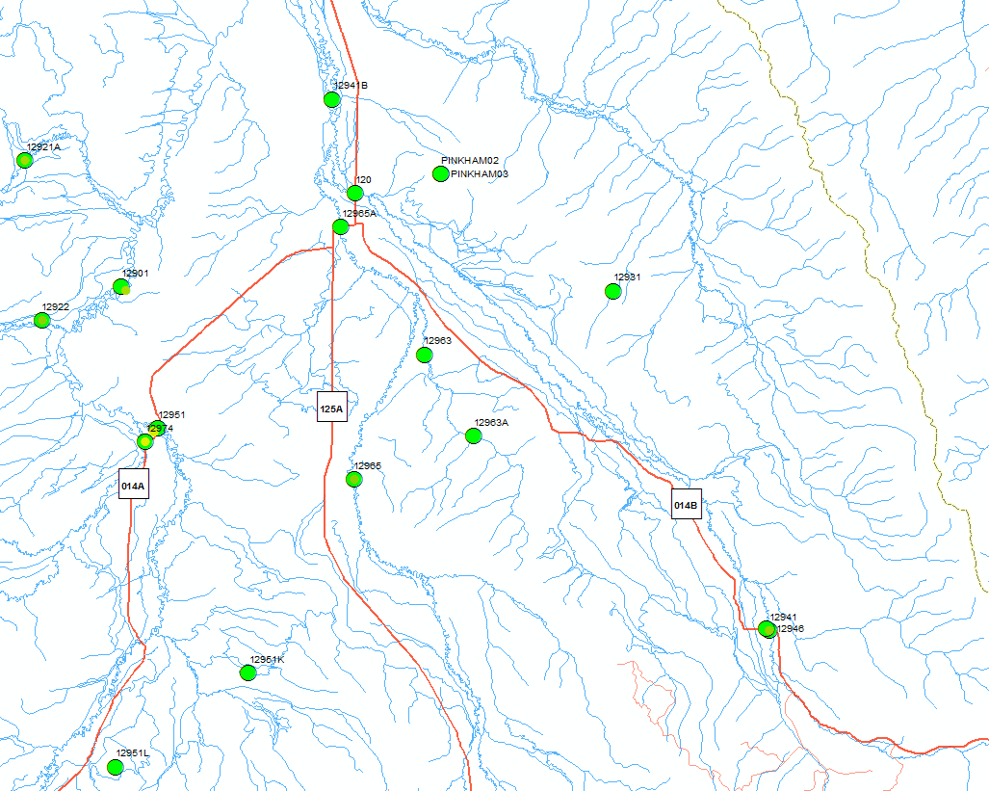

Figure 1. Michigan River near Walden

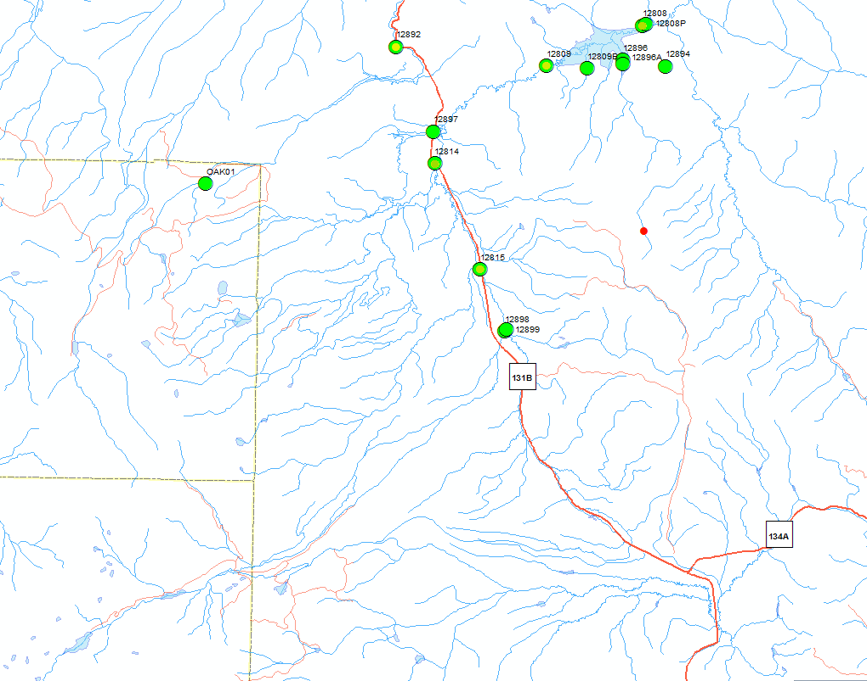

Figure 2. Bear River/Yampa abv Yampa

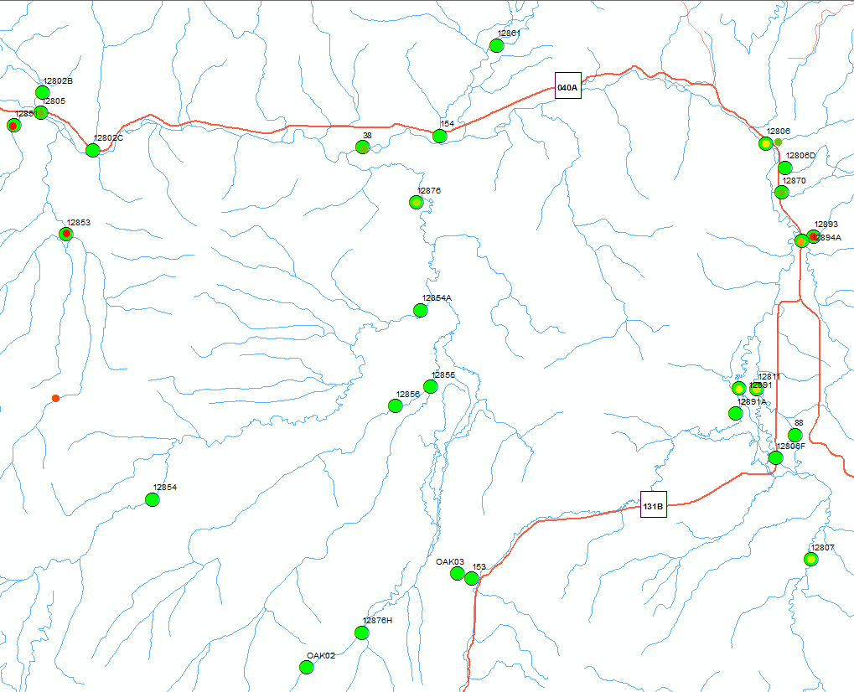

Figure 3. Yampa below Steamboat

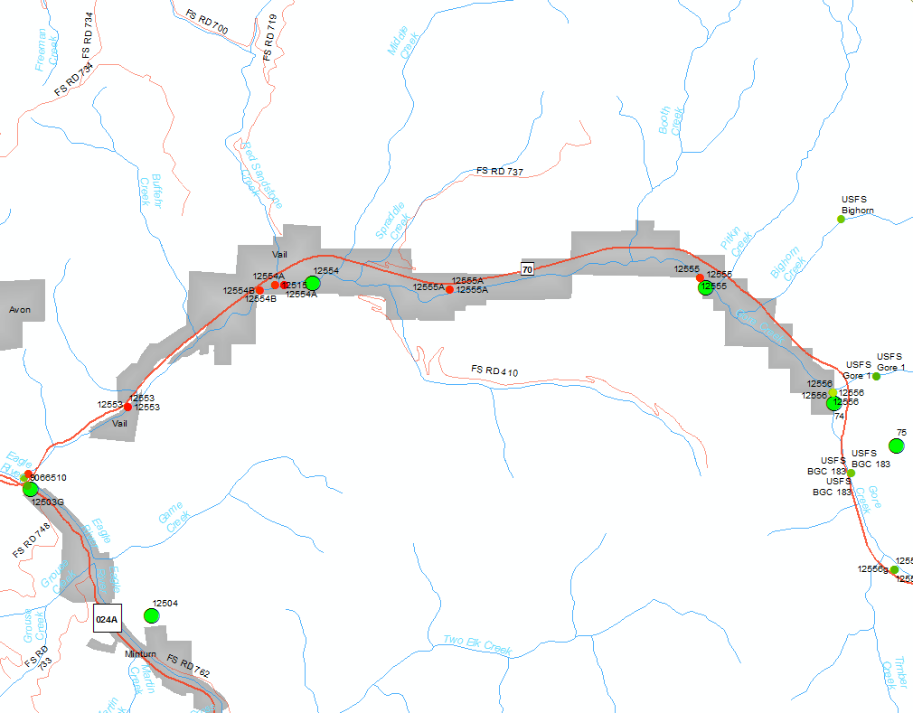

Figure 4. Gore Creek near Vail

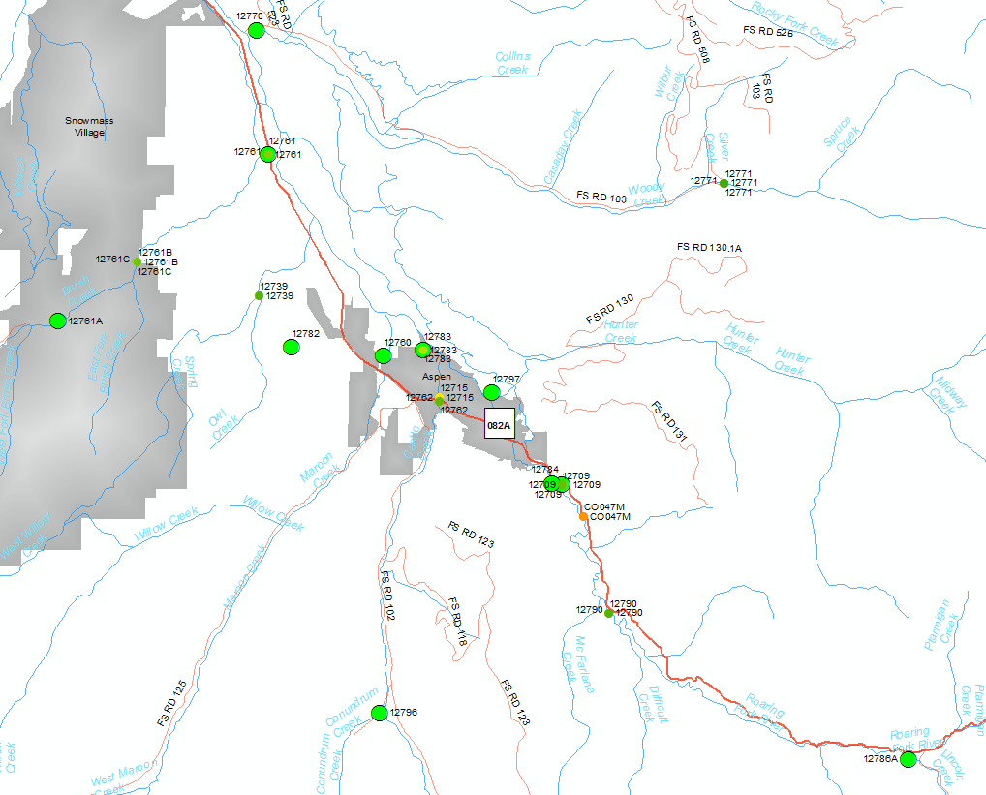

Figure 5. Roaring Fork Near Aspen

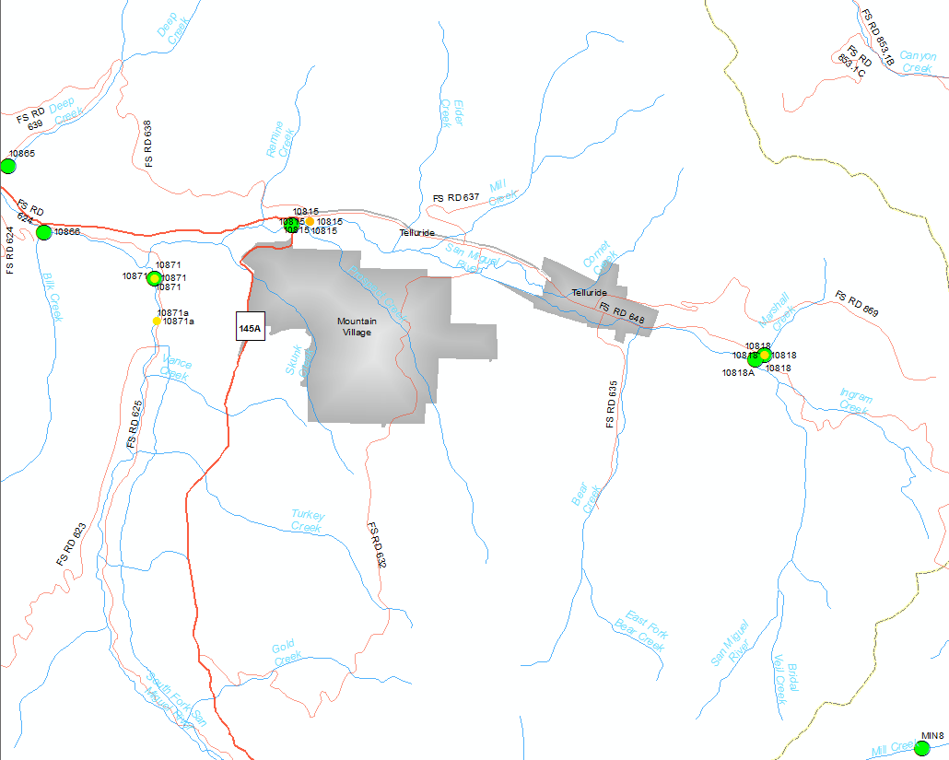

Figure . San Miguel near Telluride